Name: K.Poorna chandu
Reg No: 192312585
Subject: ECA56 –5G / 6G Communication Systems

Experiment 12: NB-IoT vs LTE-M Throughput Simulation
Aim: To simulate and compare the performance of NB-IoT and LTE-M communication
technologies in terms of Throughput (Mbps), Latency (ms), and Packet Delivery Ratio (%)
using MATLAB.
Objective 1:
Program:
clc;
clear;
close all;
% SNR values (dB)
SNR = 0:5:30;
% Simulated Throughput (Mbps)
NB_IoT = 0.05*(1-exp(-SNR/8));
LTE_M = 1.2*(1-exp(-SNR/8));

disp('SNR (dB) NB-IoT(Mbps) LTE-M(Mbps)')
disp([SNR' NB_IoT' LTE_M'])
figure
% -------- Graph 1 --------
subplot(2,1,1)
plot(SNR,NB_IoT,'-o','LineWidth',2)
title('NB-IoT Throughput vs SNR')
xlabel('Signal-to-Noise Ratio (dB)')
ylabel('Throughput (Mbps)')
grid on
% -------- Graph 2 --------
subplot(2,1,2)
plot(SNR,LTE_M,'-s','LineWidth',2)
title('LTE-M Throughput vs SNR')
xlabel('Signal-to-Noise Ratio (dB)')
ylabel('Throughput (Mbps)')
grid on
Output:
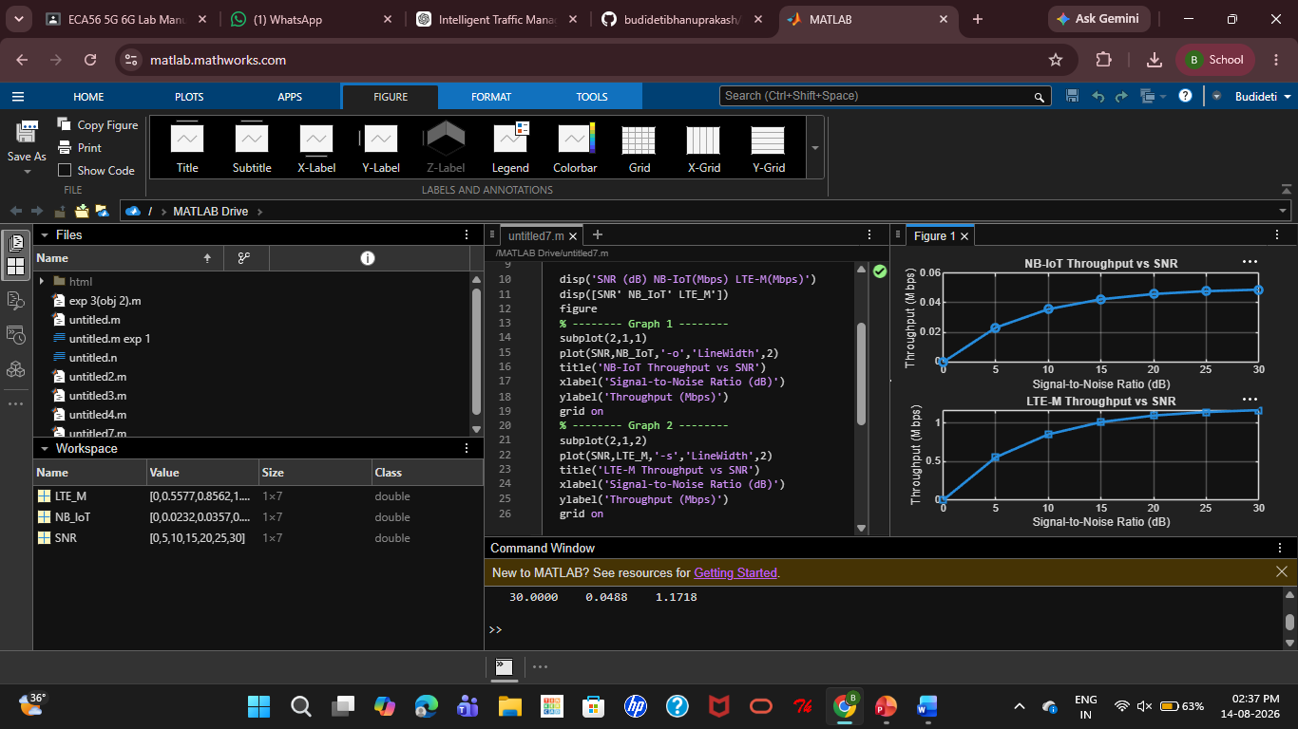

Objective 2:
Program:
clc;
clear;
close all;
% SNR values (dB)
SNR = 0:5:30;
% Simulated Latency (ms)
NB_IoT = [180 160 145 130 120 110 100];
LTE_M = [90 80 70 60 50 45 40];
disp('SNR(dB) NB-IoT Latency(ms) LTE-M Latency(ms)')
disp([SNR' NB_IoT' LTE_M'])
figure
% -------- Graph 1 --------
subplot(2,1,1)
plot(SNR,NB_IoT,'-o','LineWidth',2)
title('NB-IoT Latency vs SNR')
xlabel('Signal-to-Noise Ratio (dB)')
ylabel('Latency (ms)')
grid on
% -------- Graph 2 --------
subplot(2,1,2)
plot(SNR,LTE_M,'-s','LineWidth',2)
title('LTE-M Latency vs SNR')
xlabel('Signal-to-Noise Ratio (dB)')
ylabel('Latency (ms)')
grid on
Output:
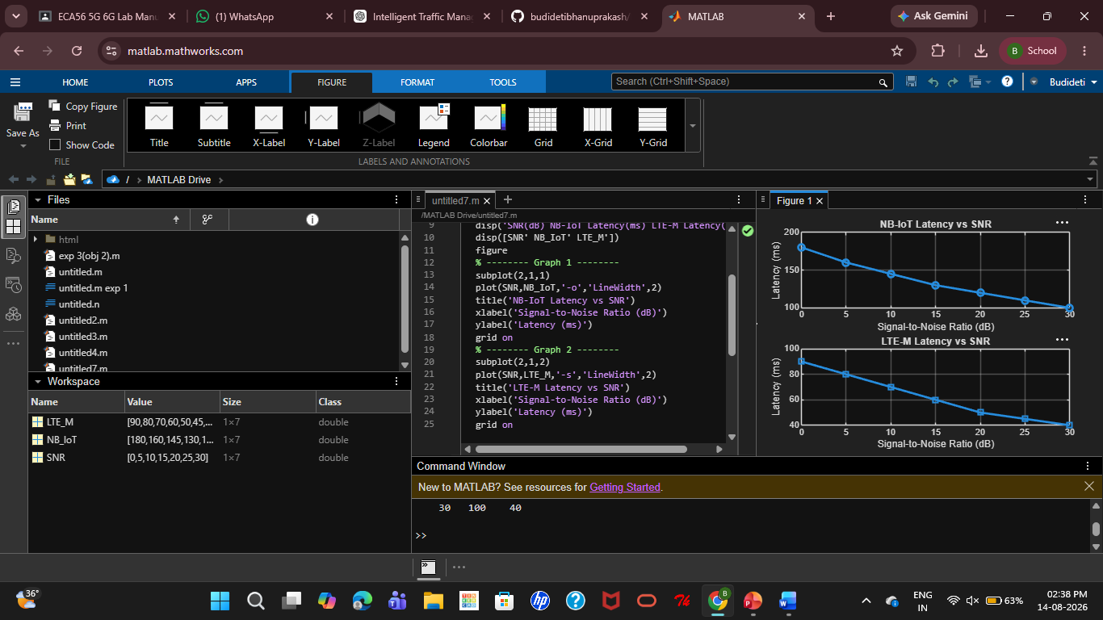
Objective 3:
MATLAB Code:
clc;
clear;
close all;
% SNR values (dB)
SNR = 0:5:30;
% Simulated Packet Delivery Ratio (%)
NB_IoT = [82 86 89 92 95 97 99];
LTE_M = [88 91 94 96 98 99 100];
disp('SNR(dB) NB-IoT PDR(%) LTE-M PDR(%)')
disp([SNR' NB_IoT' LTE_M'])
figure
% -------- Graph 1 --------
subplot(2,1,1)
plot(SNR,NB_IoT,'-o','LineWidth',2)
title('NB-IoT Packet Delivery Ratio vs SNR')
xlabel('Signal-to-Noise Ratio (dB)')
ylabel('Packet Delivery Ratio (%)')
grid on
% -------- Graph 2 --------

subplot(2,1,2)
plot(SNR,LTE_M,'-s','LineWidth',2)
title('LTE-M Packet Delivery Ratio vs SNR')
xlabel('Signal-to-Noise Ratio (dB)')
ylabel('Packet Delivery Ratio (%)')
grid on
Output:
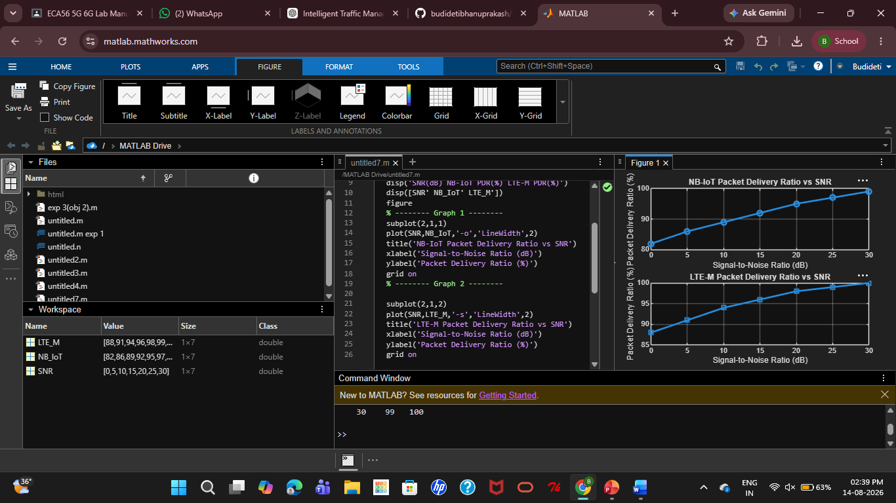
Result:
The NB-IoT and LTE-M systems were successfully simulated in MATLAB. Their Throughput, Latency, and Packet Delivery Ratio were compared under varying network conditions, and the performance of both technologies was evaluated.

